1.Use Case

提问: According to the description below, please identify actors and use cases for the system described above and show them on a UML Use Case Diagram.

Consider the following problem description: A mail-order company wants to automate its order processing. The initial version of the order processing system should be accessible to customers via the web. Customers can also call the company by phone and interact with the system via a customer representative. It is highly likely that the company will enhance this system in upcoming years with new features. The system allows customers to place orders, check the status of their orders, cancel an existing order and request a catalog. Customers may also return a product but this is only possible through the phone, not available on the web. When placing an order, the customer identifies himself by means of customer number (only for existing registered customers) or by means of his name and address. He then selects a number of products by giving the product number or by selecting products from the online catalogue. For each product, information such as price, a description and a picture (only on demand as they are usually high-resolution images of large size) are presented to the customer. Also, the availability of the product is obtained from the inventory. The customer indicates whether he wants to buy the product and in what quantity. When all desired products have been selected, the customer provides a shipping address and a credit card number and a billing address (if different from the shipping address). Then an overview of the ordered products and the total cost are presented. If the customer approves, the order is submitted. Credit card number, billing address and a specification of the cost of the order are used on the invoice, which is forwarded to the accounting system (an existing software module). Orders are forwarded to the shipping company, where they are filled and shipped. Customers who spent over a certain amount within the past year are promoted to be gold customers. Gold customers have additional rights such as being able to return products in an extended time period as well as earning more bonus points with each purchase. In addition, in cases where a product is on back order, gold customers have the option to sign up for an email notification for when the particular product becomes available.

GPT3.5给出的回答:

The actors for the order processing system can be identified as follows:

* Customer: Places orders, checks order status, cancels orders, requests a catalog, returns products by phone.
* Customer Representative: Interacts with the system on behalf of customers who call the company by phone.
* Accounting System: Receives invoices from the order processing system.
* Shipping Company: Receives orders from the order processing system and ships the products.

The use cases for the order processing system can be identified as follows:

* Place Order: Allows customers to select products, provide shipping and billing information, and submit an order.
* Check Order Status: Allows customers to check the status of their orders.
* Cancel Order: Allows customers to cancel an existing order.
* Request Catalog: Allows customers to request a catalog.
* Return Product: Allows customers to return a product by phone.
* Notify Customer: Notifies gold customers when a product becomes available.
* Promote Customer: Promotes customers to gold status if they spent over a certain amount within the past year.
* Forward Order: Forwards orders to the shipping company for fulfillment.

These use cases can be shown on a UML Use Case Diagram as follows:

gherkin

Copy

+---------------------+

| Customer |

+---------------------+

|

|

+----------+---------+ +-----------------------+

| Place Order | | Customer Representative |

+---------------------+ +-----------------------+

|

|

+----------------+---------------+

| Check Order Status |

| Cancel Order |

| Request Catalog |

| Return Product (by phone) |

+--------------------------------+

|

|

+------+--------+ +-----------------+

| Forward Order | | Shipping Company |

+------+--------+ +-----------------+

|

|

+--------------+

| Accounting System |

+--------------+

Note that the "Notify Customer" and "Promote Customer" use cases are not included in the diagram as they do not have any direct interaction with the actors or other use cases. They are more like background processes that run automatically based on certain conditions.

(询问一次,回答一次)

改进后:

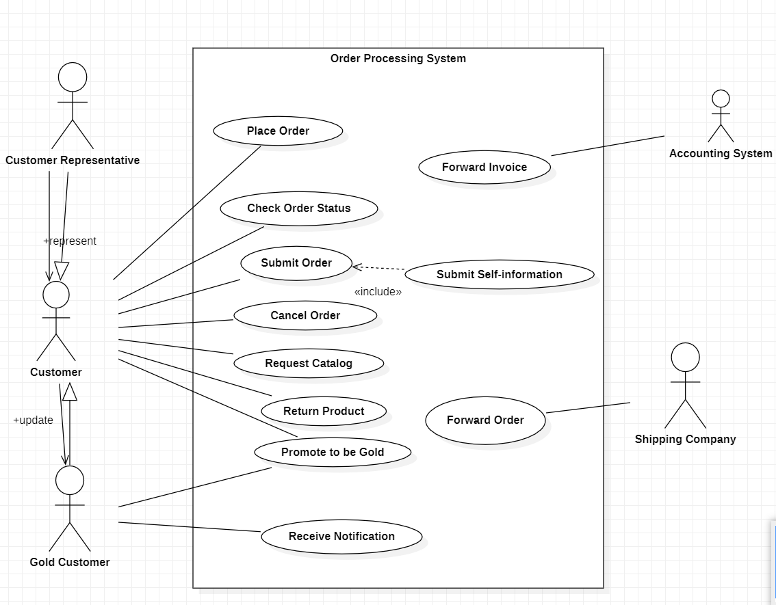

区别于相关改进:

增加了一个actor: Gold Customer,增加用例submit order, submit self-information以及forward invoice,同时也优化了一些用例的名字,如notify customer改为receive notification.

2.Class diagram

提问:

According to the description below, perform a quick application domain analysis to come up with an object model for the above system. Express your findings with a UML Class Diagram, making sure to identify any critical operations of classes.

Consider the following problem description: A mail-order company wants to automate its order processing. The initial version of the order processing system should be accessible to customers via the web. Customers can also call the company by phone and interact with the system via a customer representative. It is highly likely that the company will enhance this system in upcoming years with new features. The system allows customers to place orders, check the status of their orders, cancel an existing order and request a catalog. Customers may also return a product but this is only possible through the phone, not available on the web. When placing an order, the customer identifies himself by means of customer number (only for existing registered customers) or by means of his name and address. He then selects a number of products by giving the product number or by selecting products from the online catalogue. For each product, information such as price, a description and a picture (only on demand as they are usually high-resolution images of large size) are presented to the customer. Also, the availability of the product is obtained from the inventory. The customer indicates whether he wants to buy the product and in what quantity. When all desired products have been selected, the customer provides a shipping address and a credit card number and a billing address (if different from the shipping address). Then an overview of the ordered products and the total cost are presented. If the customer approves, the order is submitted. Credit card number, billing address and a specification of the cost of the order are used on the invoice, which is forwarded to the accounting system (an existing software module). Orders are forwarded to the shipping company, where they are filled and shipped. Customers who spent over a certain amount within the past year are promoted to be gold customers. Gold customers have additional rights such as being able to return products in an extended time period as well as earning more bonus points with each purchase. In addition, in cases where a product is on back order, gold customers have the option to sign up for an email notification for when the particular product becomes available.

Gpt3.5给出的回答:

Based on the problem description, a possible object model for the order processing system can be designed using UML Class Diagram.

The main classes that can be identified are:

1. Customer: Represents a customer of the company who can place orders.
2. Order: Represents an order placed by a customer.
3. Product: Represents a product that can be ordered by a customer.
4. Catalog: Represents the catalog of products available for ordering.
5. Inventory: Represents the inventory of available products.
6. CreditCard: Represents a credit card used for payment.
7. BillingAddress: Represents the billing address associated with a credit card.
8. ShippingAddress: Represents the shipping address for an order.
9. GoldCustomer: Represents a customer who has spent over a certain amount within the past year and has additional rights.
10. CustomerRepresentative: Represents a customer representative who interacts with the system on behalf of customers who call the company by phone.
11. AccountingSystem: Represents the accounting system that receives invoices from the order processing system.
12. ShippingCompany: Represents the shipping company that receives orders from the order processing system and ships the products.

The relationships between these classes can be shown in the following UML Class Diagram:

gherkin

Copy

+----------------+ +----------------+

| Customer | | GoldCustomer |

+----------------+ +----------------+

| - customerID | | - bonusPoints |

| - name | | |

| - address | | |

| - phone | | |

| - email | | |

| | | |

| + placeOrder()| +-------->| |

| + checkStatus()| | | |

| + cancelOrder()| | +----------------+

| + requestCatalog()| |

| + returnProduct()| |

+----------------+ |

|

+----------------+ | +----------------+

| Order | | | Product |

+----------------+ | +----------------+

| - orderID | | | - productID |

| - orderDate | | | - name |

| - status | | | - description |

| - totalCost | | | - price |

| | | | - image |

| - shippingAddress | |

| - billingAddress | |

| - paymentMethod | |

| - customer | |

| | | +----------------+

| + addProduct()| | | Catalog |

| + removeProduct()| | +----------------+

| + calculateTotalCost()| | | - products |

| + submit() |----------|------->| |

| | | | |

+----------------+ | | |

| | |

+----------------+ | +----------------+

| CreditCard | |

+----------------+ |

| - cardNumber | |

| - expirationDate | |

| | |

+----------------+ |

|

+----------------+ | +----------------+

|BillingAddress | | | Inventory |

+----------------+ | +----------------+

| - street | | | - products |

| - city | | | - quantities |

| - state | | | |

| - zipCode | | | |

| | | +----------------+

+----------------+ |

|

+----------------+ | +----------------+

|ShippingAddress | | | CustomerRepresentative |

+----------------+ | +----------------+

| - street | | | |

| - city | | | |

| - state | | | |

| - zipCode | | | |

| | | | + processOrder()|

+----------------+ | | |

| +----------------+

+----------------+ |

| ShippingCompany | |

+----------------+ |

| - name | |

| - address | |

| - phone | |

| | |

+----------------+ |

|

+----------------+ |

| AccountingSystem | |

+----------------+ |

| - invoices | |

| | |

+----------------+

(问答一次)

修改后:

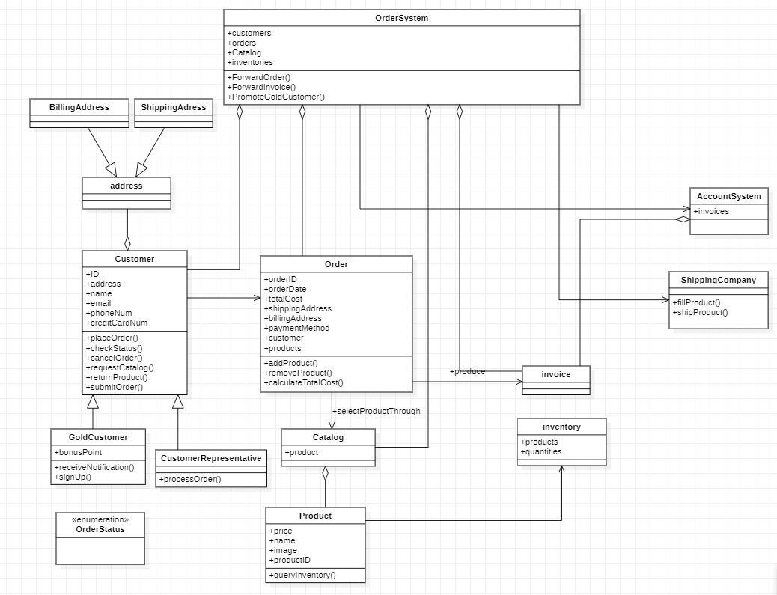

区别:

参考了各gpt答案的大部分内容,对部分类中的属性进行了修改,如:customer中层架creditCardNum属性,增加一些类的方法:如在GoldCustomer类中增加SignUp方法,以及增加了一个OrderSystem类,用于管理整个系统的相关操作.

3.SequnceDiagram

提问:

Consider the following problem description: A mail-order company wants to automate its order processing. The initial version of the order processing system should be accessible to customers via the web. Customers can also call the company by phone and interact with the system via a customer representative. It is highly likely that the company will enhance this system in upcoming years with new features. The system allows customers to place orders, check the status of their orders, cancel an existing order and request a catalog. Customers may also return a product but this is only possible through the phone, not available on the web. When placing an order, the customer identifies himself by means of customer number (only for existing registered customers) or by means of his name and address. He then selects a number of products by giving the product number or by selecting products from the online catalogue. For each product, information such as price, a description and a picture (only on demand as they are usually high-resolution images of large size) are presented to the customer. Also, the availability of the product is obtained from the inventory. The customer indicates whether he wants to buy the product and in what quantity. When all desired products have been selected, the customer provides a shipping address and a credit card number and a billing address (if different from the shipping address). Then an overview of the ordered products and the total cost are presented. If the customer approves, the order is submitted. Credit card number, billing address and a specification of the cost of the order are used on the invoice, which is forwarded to the accounting system (an existing software module). Orders are forwarded to the shipping company, where they are filled and shipped. Customers who spent over a certain amount within the past year are promoted to be gold customers. Gold customers have additional rights such as being able to return products in an extended time period as well as earning more bonus points with each purchase. In addition, in cases where a product is on back order, gold customers have the option to sign up for an email notification for when the particular product becomes available.

Draw a UML Sequence Diagram for this particular scenario. You may use any software/solution domain objects if needed as well.

The use case scenario is:

Ali is an existing customer of the order processing company described earlier, registered with their web site. Also assume that having browsed the printed catalogue he has, he already identified the two items (including their prices) he likes to buy from the company’s website using their product numbers (i.e. #2 and #9). First, he tries to buy one of product #2, but it is listed as unavailable in the inventory. Then, he adds two quantities of product #9, which turns out to be available, to his basket. He is then asked to confirm his registered shipping and billing addresses and credit card information from the customer database. He completes the order by clicking the Submit button. You may ignore processing of customer authentication.

Gpt3.5给出的回答:

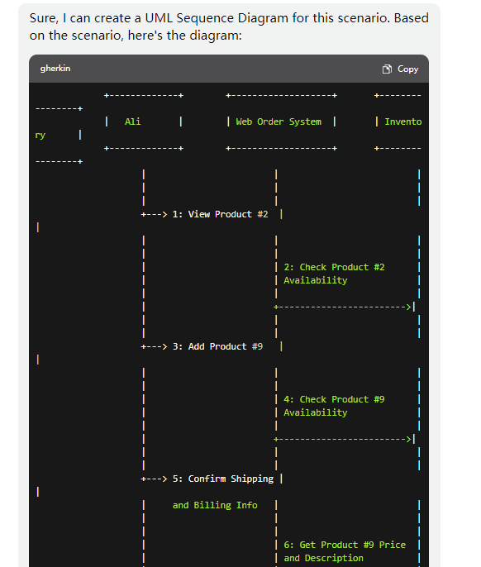

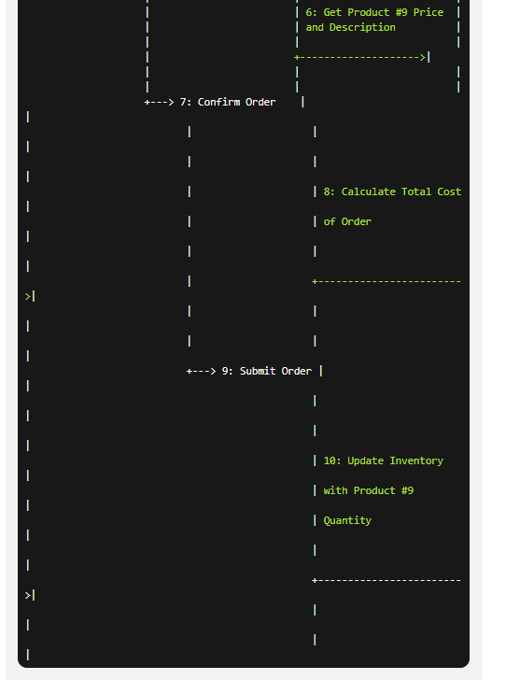  
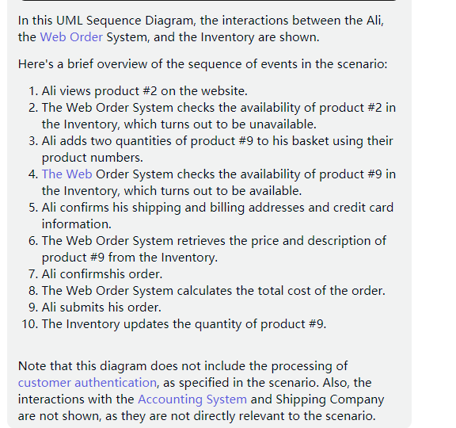

修改后:

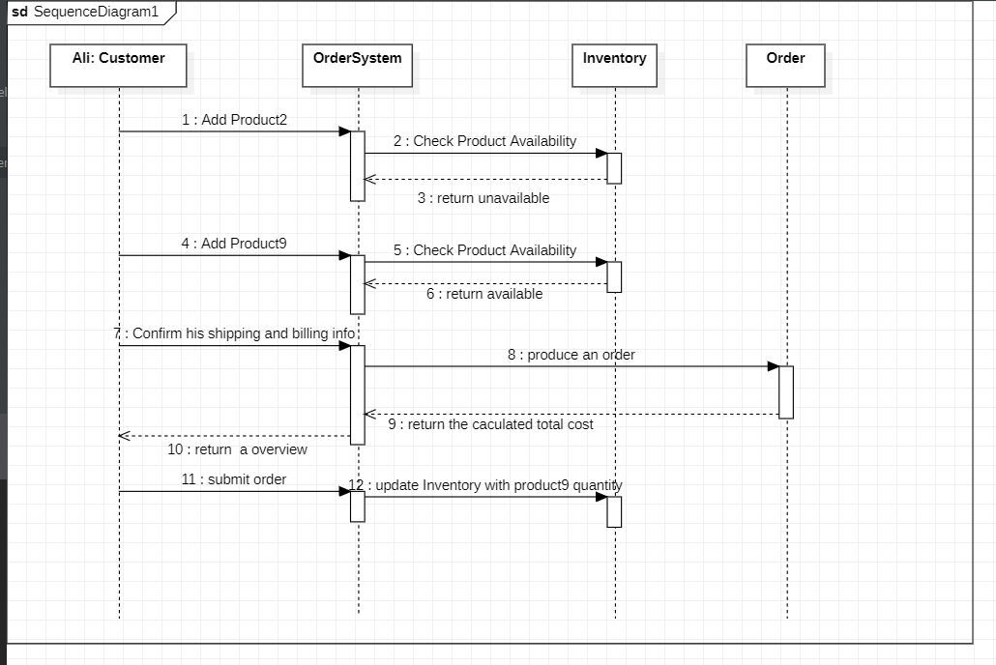

区别:

本人自己画的顺序图参考了gpt的思路,但gpt给出的答案中在一些message传输后没有返回对应的结果,因此本人加上了相关的返回结果进行完善,同时,对一些图的结构进行了修改,将gpt的confirm info和confirm order结合在一起,省去了获取商品价格和描述的细节,个人认为这样更为合理一些.